-- VERIFICAÇÃO DOS TABLESPACE - trás todas as tablespaces da instancia com suas informações de utilização

clear columns
column tablespace format a30
column total_mb format 999,999,999.99
column used_mb format 999,999,999,999.99
column free_mb format 999,999,999.99
column pct_used format 999.99
column graph format a22 heading "GRAPH (X=5%)"
column status format a10
compute sum of total_mb on report
compute sum of used_mb on report
compute sum of free_mb on report
break on report
set lines 200 pages 100
select total.ts tablespace,
DECODE(total.mb,null,'OFFLINE',dbat.status) status,
total.mb total_mb,
NVL(total.mb - free.mb,total.mb) used_mb,
NVL(free.mb,0) free_mb,
DECODE(total.mb,NULL,0,NVL(ROUND((total.mb - free.mb)/(total.mb)*100,2),100)) pct_used,
CASE WHEN (total.mb IS NULL) THEN '['||RPAD(LPAD('OFFLINE',13,'-'),20,'-')||']'
ELSE '['|| DECODE(free.mb,
null,'XXXXXXXXXXXXXXXXXXXX',
NVL(RPAD(LPAD('X',trunc((100-ROUND( (free.mb)/(total.mb) * 100, 2))/5),'X'),20,'-'),
'--------------------'))||']'
END as GRAPH
from
(select tablespace_name ts, sum(bytes)/1024/1024 mb from dba_data_files group by tablespace_name) total,
(select tablespace_name ts, sum(bytes)/1024/1024 mb from dba_free_space group by tablespace_name) free,
dba_tablespaces dbat
where total.ts=free.ts(+) and
total.ts=dbat.tablespace_name
UNION ALL
select sh.tablespace_name,
'TEMP',
SUM(sh.bytes_used+sh.bytes_free)/1024/1024 total_mb,
SUM(sh.bytes_used)/1024/1024 used_mb,
SUM(sh.bytes_free)/1024/1024 free_mb,
ROUND(SUM(sh.bytes_used)/SUM(sh.bytes_used+sh.bytes_free)*100,2) pct_used,
'['||DECODE(SUM(sh.bytes_free),0,'XXXXXXXXXXXXXXXXXXXX',
NVL(RPAD(LPAD('X',(TRUNC(ROUND((SUM(sh.bytes_used)/SUM(sh.bytes_used+sh.bytes_free))*100,2)/5)),'X'),20,'-'),
'--------------------'))||']'
FROM v$temp_space_header sh
GROUP BY tablespace_name
order by 6
/

ttitle off
rem clear columns

###########################################################################################################################################

--VERIFICAÇÃO DOS DATAFILES - trás as informações da tablespace como: datafiles, tamanhos, autoextend, etc: ' M4U_DATA '

compute sum of SIZE on report
col file_name for a60
break on report
select file_id, file_name,tablespace_name,status, bytes/1024/1024 "SIZE" , AUTOEXTENSIBLE,BLOCKS, MAXBYTES,INCREMENT_BY, MAXBLOCKS
from dba_data_files
where TABLESPACE_NAME = ‘SAGE_DADOS’
order by 2
/

14

*****TABLESPACE TEMPORARIA
compute sum of SIZE on report
col file_name for a60
break on report
select file_id, file_name,tablespace_name,status, bytes/1024/1024 "SIZE" , AUTOEXTENSIBLE,BLOCKS, MAXBYTES,INCREMENT_BY, MAXBLOCKS
from dba_TEMP_files
where TABLESPACE_NAME ='AC1QP0T01'
order by 2
/

compute sum of SIZE on report
col file_name for a60
break on report
select file_id, file_name,tablespace_name,status, bytes/1024/1024 "SIZE" , AUTOEXTENSIBLE,BLOCKS, MAXBYTES,INCREMENT_BY, MAXBLOCKS
from dba_data_files
where TABLESPACE_NAME like '%ACSST01%'
order by 2
/

###########################################################################################################################################

--NO ASM - trás as informações de espaço dos DISKGROUPS no ASM

SELECT NAME DISKGROUP, TOTAL_MB, FREE_MB, (TOTAL_MB-FREE_MB)/TOTAL_MB*100 PCT_UTILIZADO FROM V$ASM_DISKGROUP;

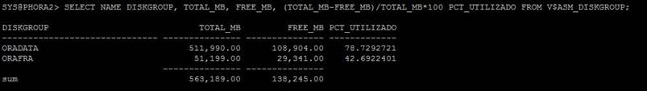

SELECT NAME DISKGROUP, TOTAL_MB, FREE_MB, ROUND((TOTAL_MB-FREE_MB)/TOTAL_MB*100,1) PCT_UTILIZADO FROM V$ASM_DISKGROUP;

###########################################################################################################################################

-- AUMENTAR DATAFILE - No caso de um datafile que não esteja com tamanho máximo de 32767, efetua o resize do datafile

alter database datafile 74 resize 224000m;

No caso de um datafile em DISCO, seguimos com:
df -h * para verificar onde há espaço disponível para criação do datafile

###########################################################################################################################################

-- ADD DATAFILE - Adiciona um novo datafile a tablespace:

***O tamanho pode ser definido em MB: 100m ou GB: 1g
alter tablespace CFRLANX add datafile '+DATA_CF' size 32767m autoextend off;

alter tablespace UNDOTBS1 add datafile '+DATA' size 32767m autoextend off;

alter tablespace PSAPXGS add datafile '/oracle/BSP/sapdata10/xgs.data166' size 32767m autoextend off;
alter tablespace PSAPXGS add datafile '/oracle/BSP/sapdata12/xgs.data167' size 32767m autoextend off;
alter tablespace PSAPXGS add datafile '/oracle/BSP/sapdata12/xgs.data168' size 32767m autoextend off;

alter tablespace GW_DATA add datafile 'D:\APP\ORACLE\ORADATA\TMSDBP\STATSPACK_DATA02.DBF' size 1200m autoextend off;

'/u21/oradata/BIPROD/TS_DWD_DATA_IS_RW_102.dbf' size 32767m; --

###########################################################################################################################################

show parameter db_create - mostra o caminho setado no banco para criação de datafile

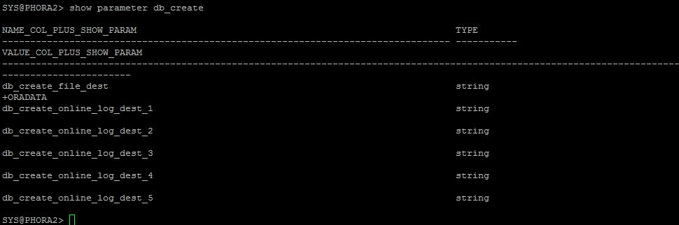
si

###########################################################################################################################################

-- MOVER DATAFILE PARA ASM

alter database move datafile '/u01/app/oracle/oradata/orcl/teste.dbf' to '+DG01';

###########################################################################################################################################

--MOVER DATAFILE PARA DISCO

alter database move datafile '+DG01' to '/u01/app/oracle/oradata/orcl/teste.dbf'

###########################################################################################################################################

--RENOMEANDO DATAFILE

alter database move datafile '/u01/app/oracle/oradata/orcl/tb_teste.dbf' to '/u01/app/oracle/oradata/orcl/teste.dbf';

###########################################################################################################################################

-- DROP DATAFILE DO TABLESPACE

ALTER TABLESPACE TBS_USER_TA DROP DATAFILE '/u07/app/oracle/product/11.2.0/tdazul_p4/dbs/DGDATA02';

/u21/oradata/BIPROD/TS_DWD_DATA_IS_RW_101.dbf

###########################################################################################################################################

--ALTERANDO TAMANHO DE TABLESPACE TEMPORARIA

SELECT tablespace_name, FILE_ID, file_name, bytes/1024/1024 "SIZE MB" FROM dba_temp_files WHERE tablespace_name like '%TEMP%';

SELECT tablespace_name, FILE_ID, file_name, bytes/1024/1024 "SIZE MB" FROM dba_temp_files WHERE tablespace_name like '%ACSST01%';

alter database tempfile 1 resize 200m;

###########################################################################################################################################

/oradata/acssp0/temp01/temp/

